Contents

1 Technology Comparison 1

1.1 Ultrasonic 1

1.2 Radar 1

2 Ultrasonic Sensor Options 2

2.1 Multicomp MCUSD14A58S9RS-30C 2

2.2 MJK Shuttle 2

3 Radar Sensing Options 2

3.1 Acconeer X112 Dev-kit 2

3.1.1 XC112 Connector Board 2

3.1.2 XR112 Radar Sensor Board 2

3.1.3 LH122 Radar Lens 2

3.2 Infineon BGT60LTR11AIP 3

3.2.1 Radar MMIC 3

3.2.2 Shield 3

3.2.3 Radar Baseboard MCU7 3

3.3 VEGAPULS C 21 3

# 1 Technology Comparison

## 1.1 Ultrasonic

* Ultrasonic transducers & sensors generate/sense ultrasound energy – sound waves w/ freq. > upper limit of human hearing
* 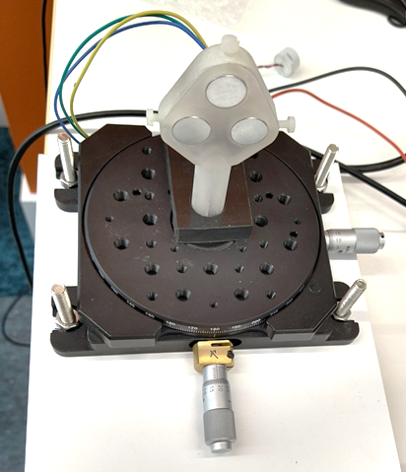Can be divided into three broad categories: transmitters, receivers, transceivers
  + Transmitters convert electrical signals into ultrasound
  + Receivers convert ultrasound into electrical signals
  + Transceivers can both transmit and receive ultrasound
* Widely available, but wide beam angle means combination of 3+ sensors in array needed to collimate beam – slightly more involved and bulkier

## 1.2 Radar

* RAdio Detection And Ranging – use of radio waves to determine distance (range), angle, or velocity of objects.
* Radar system consists of:
  + Transmitter producing electromagnetic waves in radio/microwave domain
  + Transmitting and receiving antenna, a receiving antenna (often same antenna)
  + Receiver and processor to determine properties of object(s)
* Radio waves (pulsed or continuous) from transmitter reflect off object and return to receiver, giving info about object's location and speed
* Only a lens will be needed to focus beam

# 2 Ultrasonic Sensor Options

## MULTICOMP MCUSD14A58S9RS-30C2.1 Multicomp MCUSD14A58S9RS-30C

* Ultrasonic transceiver; [farnell.com](https://uk.farnell.com/multicomp/mcusd14a58s9rs-30c/transceiver-58khz-14mm-metal/dp/2362684)
* 14mm diameter, 58 kHz
* £5.04 each… £2.35 for 150+
* 100° beam angle, so need to combine 3 in array
* 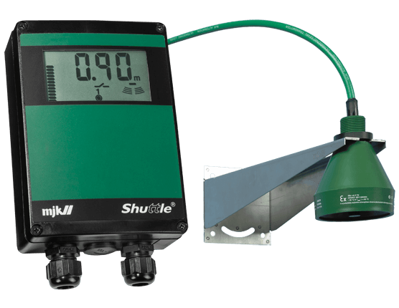Will require other components, e.g. [signal processor](https://www.ti.com/product/PGA450-Q1), capacitor, transformer, converter

## 2.2 MJK Shuttle

* <https://mjk.com/mjk-product-line/level-measurement/ultrasonic>
* Seems to require rather high power

# 3 Radar Sensing Options

## 3.1 Acconeer X112 Dev-kit

### 3.1.1 XC112 Connector Board

* Can connect up to four XR112 radar sensor boards
* Designed for use with Raspberry Pi 3
* £143.95 unit price (excluding VAT) [from DigiKey](https://www.digikey.co.uk/product-detail/en/acconeer-ab/XC112/1891-1004-ND/9356272)

### 3.1.2 XR112 Radar Sensor Board

* Connected to XC112 via flat flexible cable (included)
* 20mm x 20mm
* 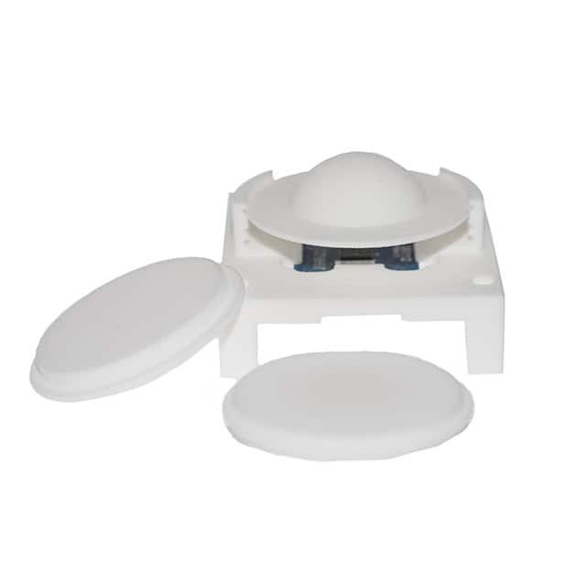£35.22 unit price (excluding VAT) [from DigiKey](https://www.digikey.co.uk/product-detail/en/acconeer-ab/XR112/1891-1003-ND/9356271)

### 3.1.3 LH122 Radar Lens

* <https://www.digikey.co.uk/product-detail/en/acconeer-ab/LH122/1891-LH122-ND/11688416>
* £27.14 unit price (excluding VAT)

## 3.2 Infineon BGT60LTR11AIP

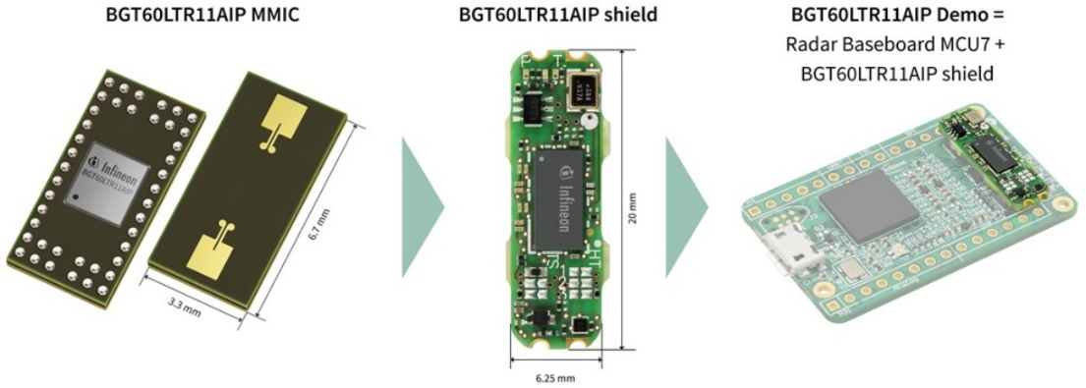<https://www.infineon.com/cms/en/product/evaluation-boards/demo-bgt60ltr11aip/>

### 3.2.1 Radar MMIC

* 60 GHz
* 3.3 x 6.7 x 0.56 mm
* 80° FOV

### undefined3.2.2 Shield

* 20 x 6.25 mm
* Form factor compatible with Arduino MKR; or with included baseboard

### 3.2.3 Radar Baseboard MCU7

* USB 2.0 interface
* Compatible with Arduino MKR standard

## 3.3 VEGAPULS C 21

### <https://www.vega.com/en-uk/products/product-catalog/level/radar/vegapuls-c-21>

* 8° beam angle

